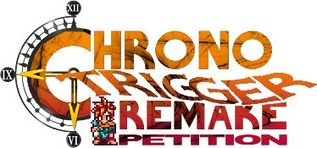

To: Square Enix Co., Ltd.
Date: July 30, 2026
Re: Chrono Trigger Remake

To Whom It May Concern:
We are Chrono Trigger fans who believe the time has come for Square Enix Co., Ltd., to remake the game. Several recent fan attempts to produce a remake reflect that belief.
The original release of Chrono Trigger on the Super Nintendo Entertainment System gave players an unprecedented sense of involvement. Those players became and remained fans, and the re-release of Chrono Trigger on PlayStation further broadened the fan base. Using recent advances in game-making technology to remake the game would give those fans access to a system more capable of presenting the game's complex world, storyline, and characters.
We can promise our own enthusiastic support for a remake, and we expect that other fans will do the same. Those who are not yet fans will have an additional and powerful reason to join us.
Thank you for your time,
________________________________ ___________________________________
________________________________ ___________________________________
________________________________ ___________________________________
________________________________ ___________________________________
________________________________ ___________________________________
________________________________ ___________________________________
________________________________ ___________________________________
________________________________ ___________________________________
________________________________ ___________________________________
________________________________ ___________________________________

"Chrono Trigger," the Chrono Trigger logo, Crono, Marle, Lucca, Ayla, Frog, Robo, Magus, Lavos, and their likenesses are trademarks of SQUARE-ENIX CO., LTD. Fan artwork copyright Abby Perry.

